**Welcome Screen:**

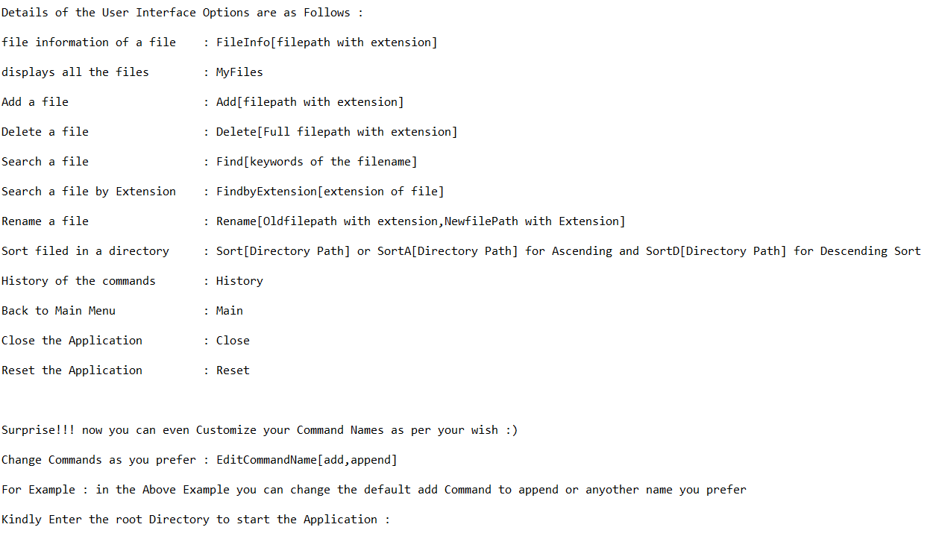

**Root Directory:** root Directory to be set by the user to start the application

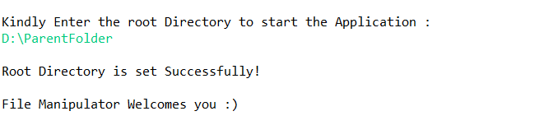

**File Information:** Displays all the information that can be captured from a file

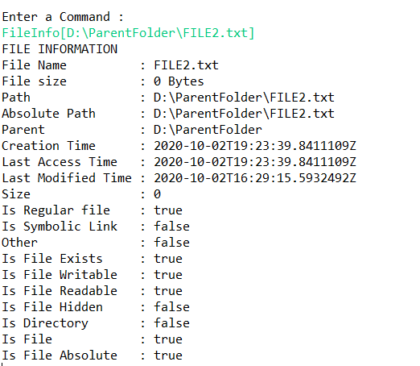

**MyFiles:** Displays all the Files Recursively from the Root Directory

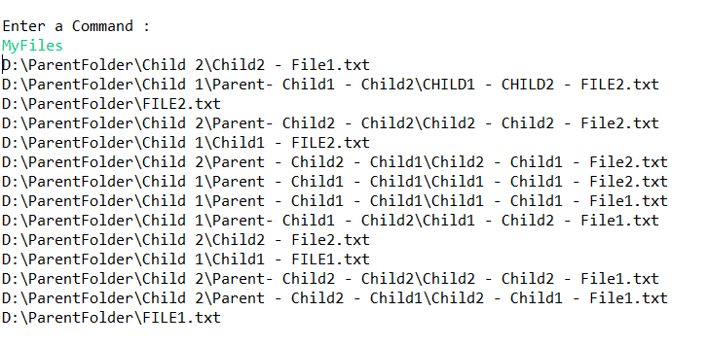

**Add a File – Add[FilePath] :** creates a new file in the mentioned repository

**Folder before Add:**

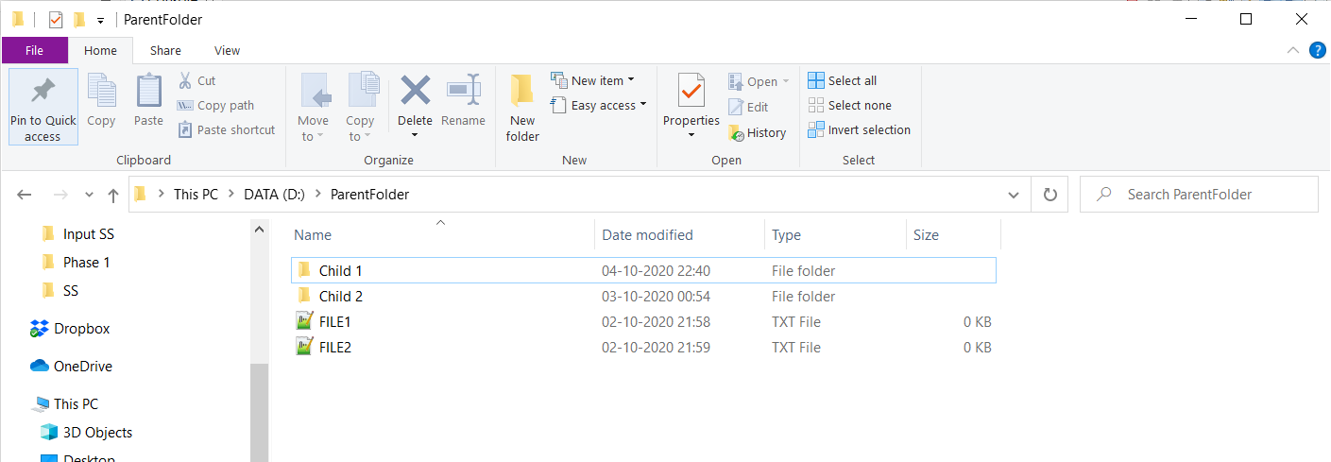

**Add Command:**

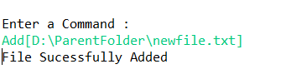

**Folder after Add:**

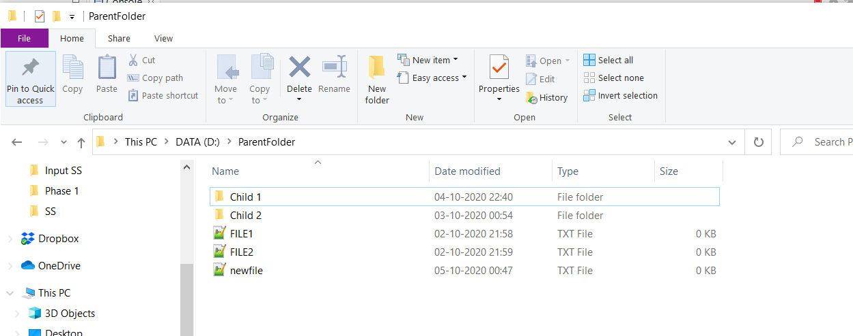

**Delete a File – Delete[FilePath] :** deletes a file in the mentioned directory

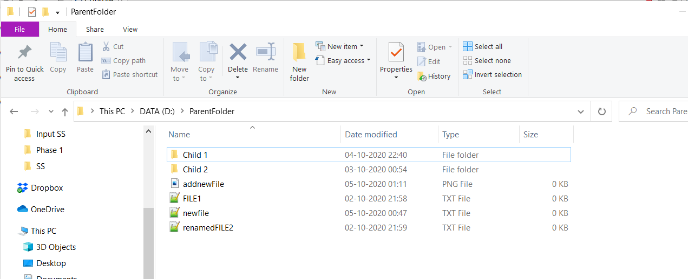

**Delete Command:**

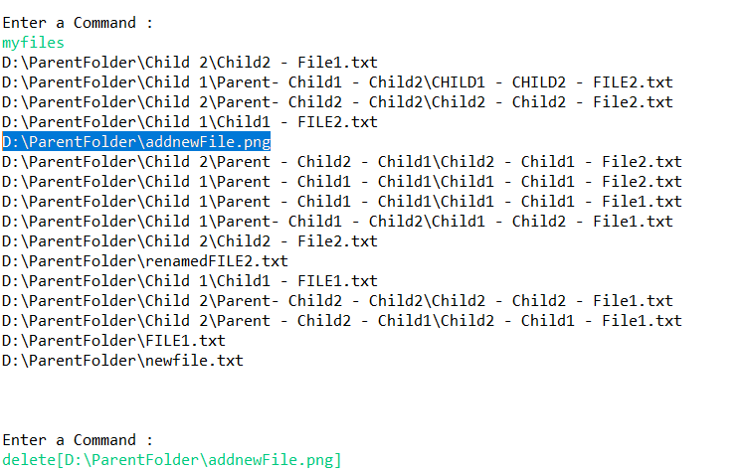

**Folder after Delete:**

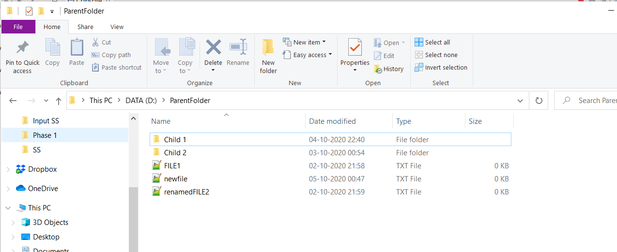

**Find Command:**

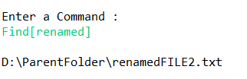

**Find by Extension Command:**

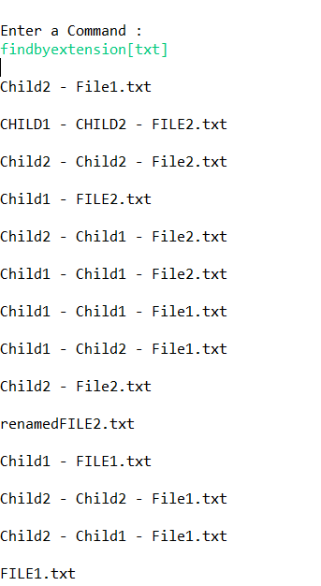

**Rename a file:** Rename[full File path with existing name, full file path with new name]

**Folder before Rename:**



**Rename Command:**

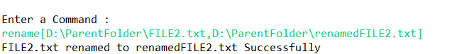

**Folder after Rename:**

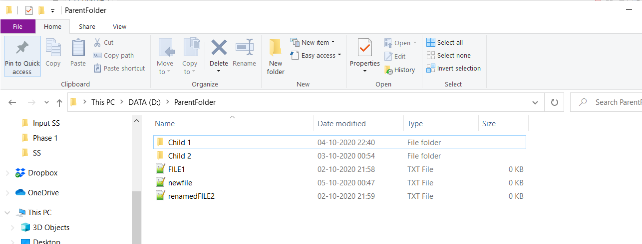

**Ascending sort: SortA[Directory path] -** Sorts a file in Ascending order as per alphabets

**SortA Command:**

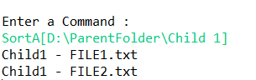

**Descending sort: SortD[Directory path] -** Sorts a file in Descending order as per alphabets

**SortD Command:**

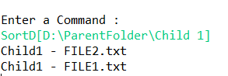

**History Command:** Displays the previous commands used by the user

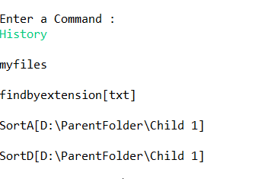

**Close Command:**

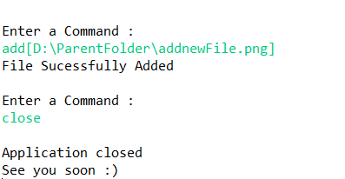

**Main Command:** Main Command goes back to the main screen where the information is displayed

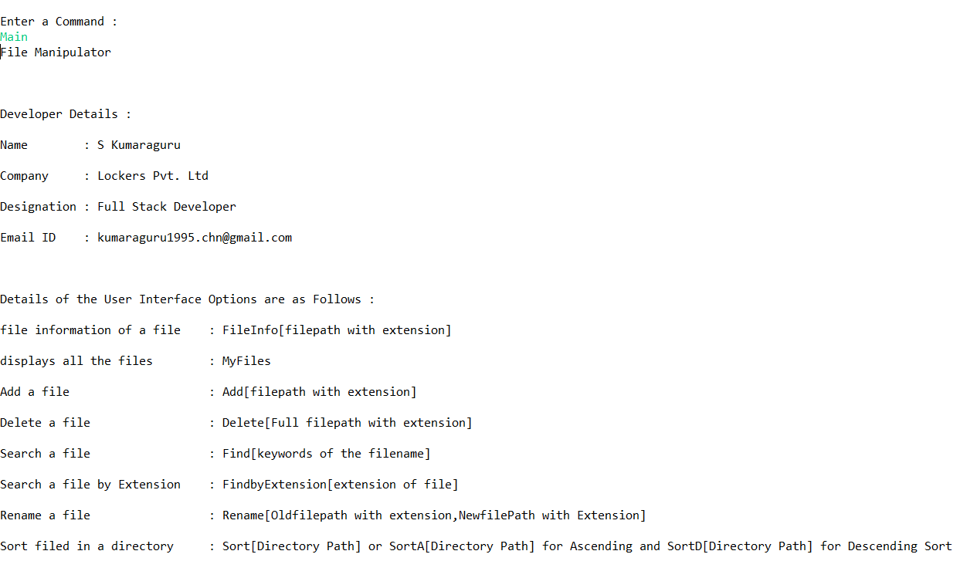

**Reset Command:** reset command resets history and clears all the values associated previously

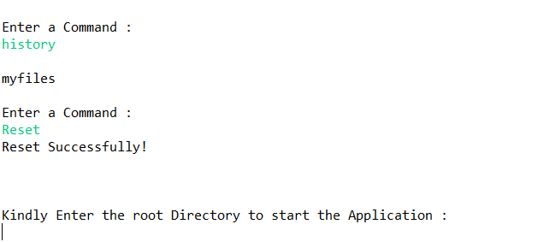

The End